**Agile Meetings**

**Introduction to Agile and Importance of Meetings**

Agile is a modern software development methodology that emphasizes flexibility, customer satisfaction, and incremental delivery. Unlike traditional waterfall approaches, Agile promotes adaptive planning, early delivery, and continuous improvement. One of the core pillars of Agile is **effective communication**, which is achieved through a structured set of meetings known as **Agile ceremonies** or **Agile events**.These meetings are not arbitrary; they are carefully designed to enhance transparency, foster collaboration, and facilitate quick decision-making. They serve as checkpoints where teams can inspect progress and adapt their plans accordingly.Agile frameworks like Scrum, Kanban, and SAFe (Scaled Agile Framework) each have their variations of these meetings, but the most commonly followed are derived from **Scrum**.

The primary Agile meetings include:

* Sprint Planning
* Daily Scrum (Stand-up)
* Sprint Review
* Sprint Retrospective
* Backlog Refinement (or Grooming)

1. **Sprint Planning:**

**Objective**: To define what can be delivered in the upcoming sprint and how the work will be achieved.

**When**: At the beginning of every sprint (usually bi-weekly or monthly).

**Duration**: 2–4 hours for a 2-week sprint.

**Participants**: Product Owner, Scrum Master, Development Team.

**Key Activities**:

* The Product Owner presents the prioritized Product Backlog.
* The team discusses and selects items (user stories or tasks) to include in the Sprint Backlog.
* Tasks are broken down and estimated in terms of effort.
* The team commits to the scope of work they believe is achievable.

**Outcomes**:

* A clear Sprint Goal.
* A well-defined Sprint Backlog.
* Mutual understanding and alignment between the team and the Product Owner.

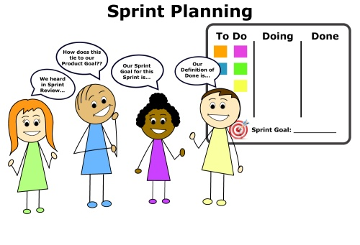

#### ****Daily Stand-up (Daily Scrum)****

**Objective**: To synchronize activities and identify impediments.

**When**: Every working day of the sprint.

**Duration**: 15 minutes maximum.

**Participants**: Development Team (Scrum Master and Product Owner may attend but typically as observers).

**Format**:  
Each team member answers three questions:

1)What did I do yesterday?

2)What will I do today?

3)Are there any impediments in my way?

**Benefits**:

* Promotes accountability.
* Encourages quick identification of blockers.
* Keeps the team aligned and focused.

**Best Practices**:

* Stay within time limits.
* Avoid turning it into a problem-solving meeting.
* Use a consistent time and location.

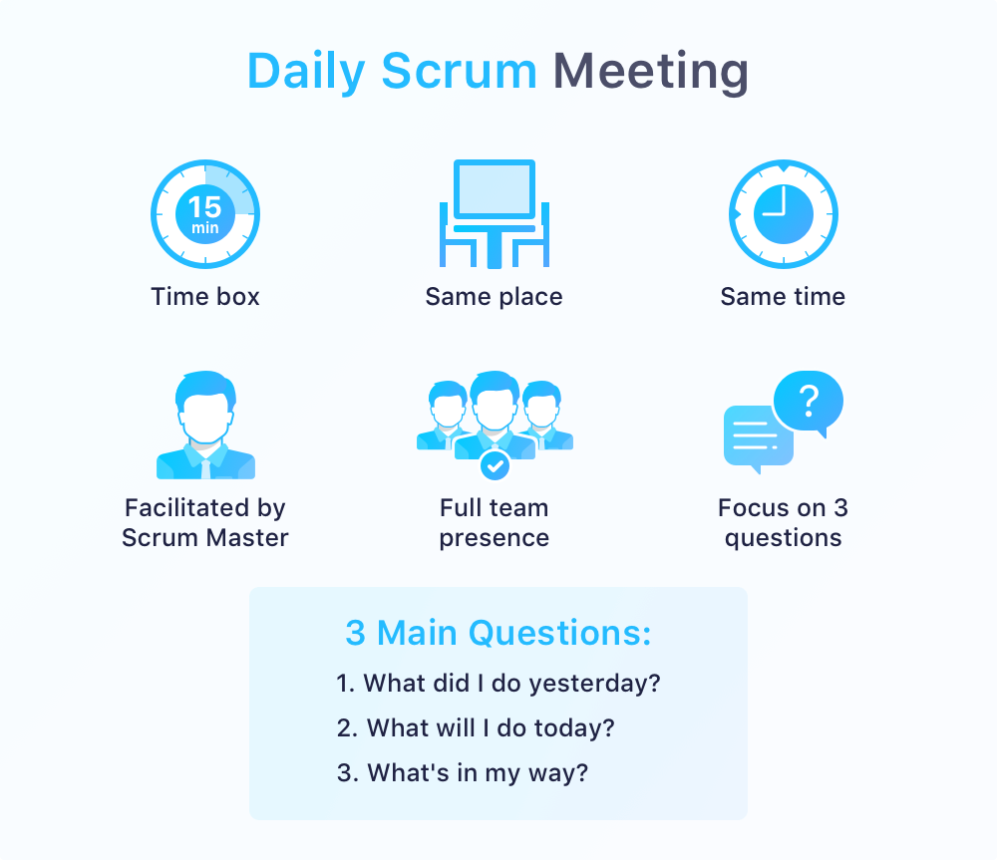v

1. **Sprint Review**

**Objective**: To inspect the product increment and adapt the Product Backlog if needed.

**When**: At the end of each sprint.

**Duration**: 1–2 hours for a 2-week sprint.

**Participants**: Development Team, Product Owner, Scrum Master, Stakeholders.

**Activities**:

* The team demonstrates the work completed during the sprint.
* Stakeholders provide feedback.
* The Product Owner discusses the current Product Backlog and potential delivery dates.
* New items may be added to the backlog based on feedback.

**Outcomes**:

* A shared understanding of what was completed.
* Realignment of the product roadmap based on user and stakeholder feedback.

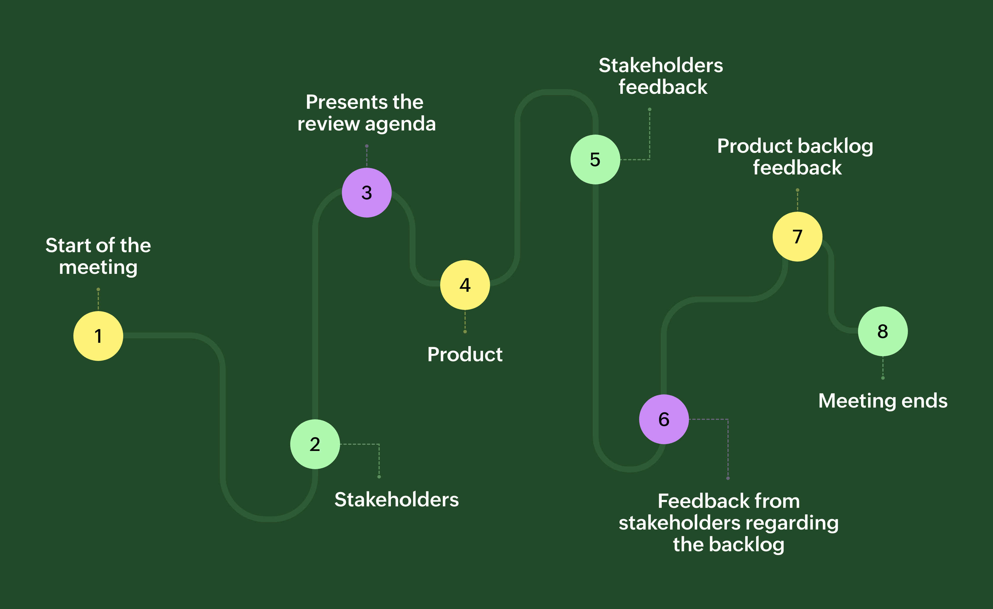

1. **Sprint Retrospective**

**Objective**: To reflect on the sprint and identify improvements.

**When**: After the Sprint Review and before the next Sprint Planning.

**Duration**: 1–1.5 hours for a 2-week sprint.

**Participants**: Scrum Master, Development Team (Product Owner is optional).

**Key Topics**:

* What went well during the sprint?
* What didn’t go well?
* What can be improved in the next sprint?

**Tools Used**:

* Start/Stop/Continue
* 4Ls (Liked, Learned, Lacked, Longed for)
* Mad/Sad/Glad

**Outcomes**:

* Actionable improvements.
* A more collaborative and self-aware team.

**Role of Scrum Master**:  
Facilitates the meeting, ensures a safe environment for honest communication, and tracks improvement actions over time.

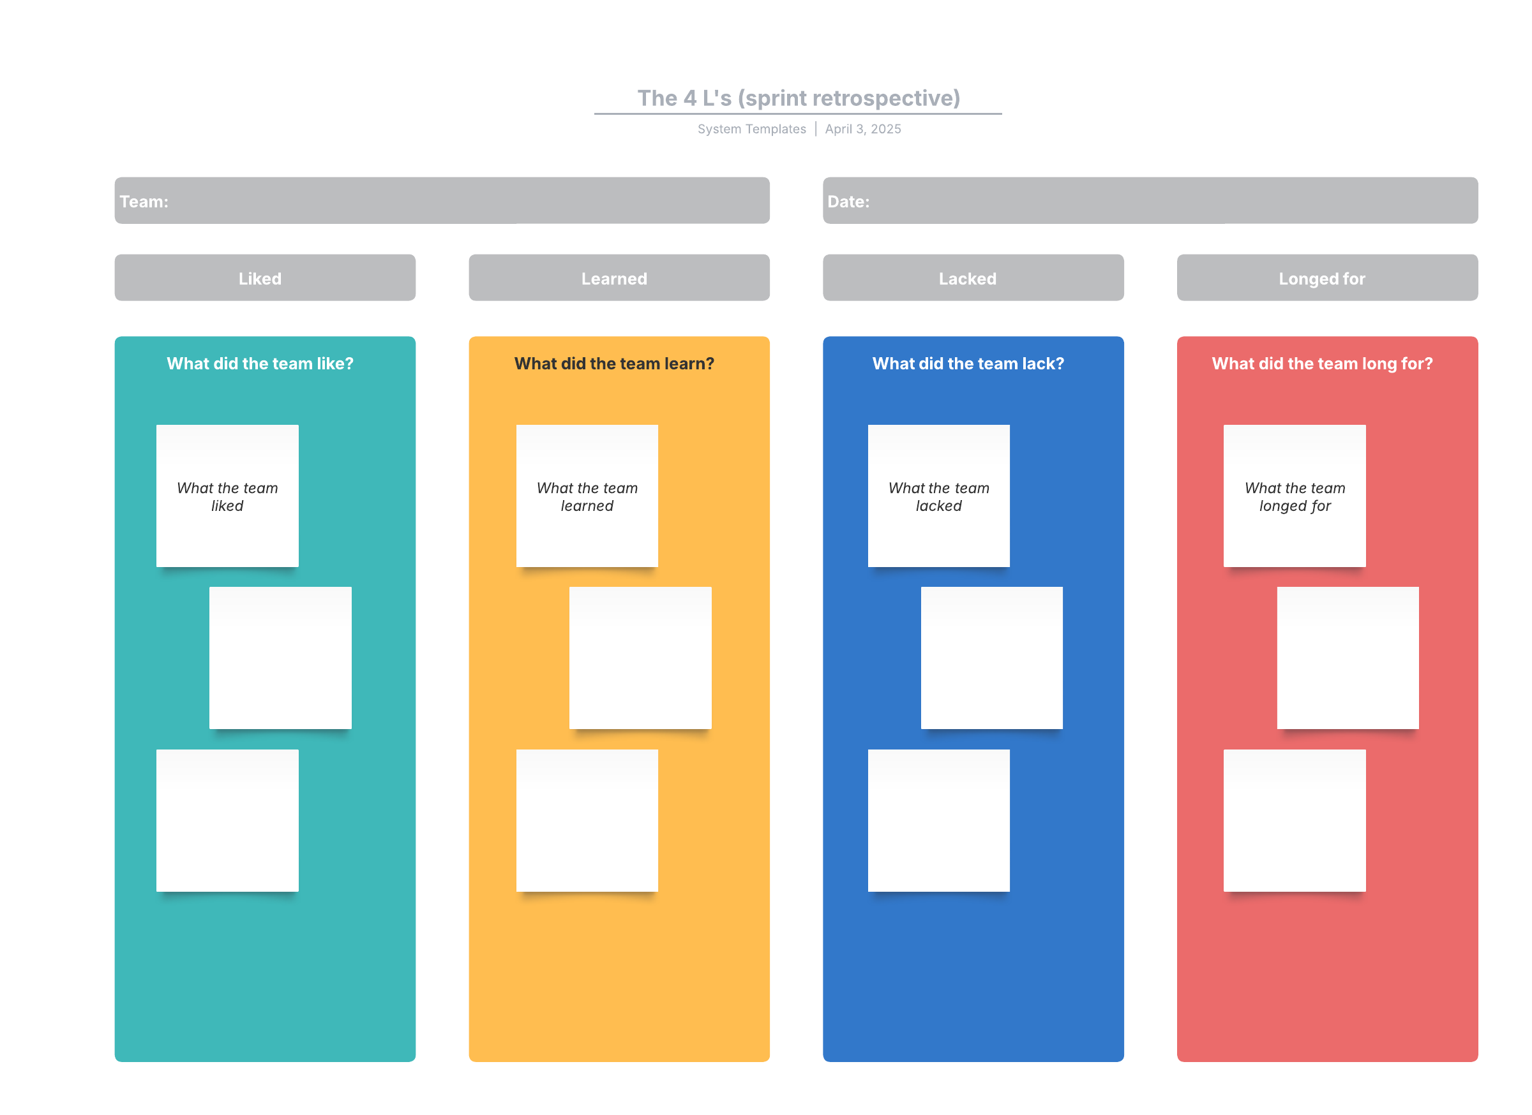

1. **Backlog Refinement**

**Objective**: To keep the Product Backlog clean, prioritized, and ready for Sprint Planning.

**When**: Ongoing (often once or twice a week).

**Duration**: 1–2 hours per week.

**Participants**: Product Owner, Development Team, Scrum Master (optional).

**Activities**:

* Adding new user stories.
* Clarifying existing stories.
* Estimating and re-estimating items.
* Splitting large stories into smaller, manageable ones.
* Removing outdated or irrelevant items.

**Benefits**:

* Makes Sprint Planning smoother.
* Ensures high-priority items are well-understood.
* Helps the team remain agile and adaptive.

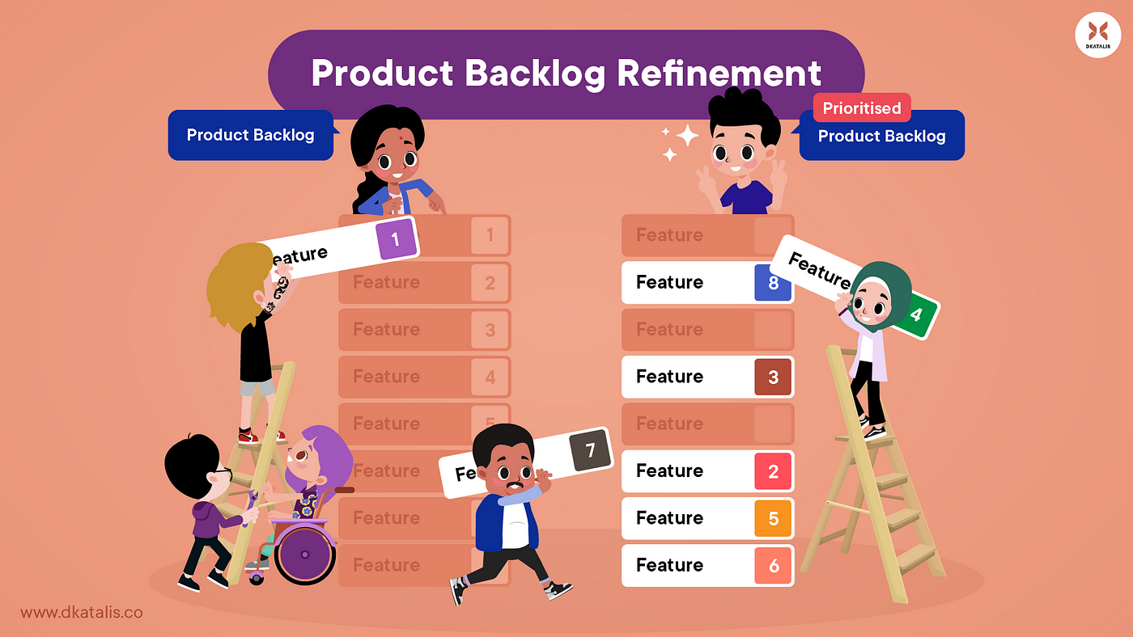

### ****Conclusion: Agile Meetings – The Heartbeat of Delivery****

Agile meetings serve as the **communication backbone** of an Agile team. They ensure that:

* Everyone is aligned on goals.
* Progress is continuously inspected.
* Adaptations are made quickly.
* Teams remain motivated and productive.

While some may see these meetings as overhead, when done correctly, they are **short, focused, and invaluable**. They foster a culture of transparency, ownership, and continuous learning, which are the essence of Agile itself.